
Permit Application #2000.6 LPG Tank Installation- Permanent - 125 gallons or less

Tacoma Fire Department
Fire Prevention Division 253.591.5740
FAX Number 253.594.7943
3471 S. 35th St. Tacoma, WA 98409
www.tacomafiredepartment.org

Submit Paper Work by Hand, Mail, Fax, E-mail to: TFDHMO@cityoftacoma.org
To be completed by the Permit Applicant (type in the grey box or print out and complete)

Business Information
Date: |  |  |  | Projected install date:
Business Name: |  |  |  | Federal Tax ID: |  |  | UBI:
Address: | Street: |  |  | City: |  | State: |  | Zip:
Site Address: | (if different from above)
Contact Name:
Phone: | ( ) |  |  | Alternate Phone/Cell: ( )
E-mail Address:
City of Tacoma  Business License: | Washington State  Contractor License:
Comments:

Please include a check made payable to the CITY OF TACOMA TREASURER, or request an invoice.
Check this box to have applicant invoiced for the permit fee.

FPB OFFICIAL USE ONLY
Approved By: |  |  | Date:
Denied: | Reason for Denial:
Comments:
Permit Number:
Permit Fees: | Date Received: | Receipt Number: |  |  | Check Number:
Tacoma Fire Department Seal Number:

See attached documentation for description of conditions that must be met prior to the issuance of this permit.
-LPG-

Tacoma Fire Department

PERMIT CONDITIONS: 2000.6 LPG Tank - 125 gallons or less

1. Time Lines
- Applications with are required to be submitted 14 days in advance for review prior to permit being issued.

2. Regulatory References
- International Fire Code Chapter 38; and Sections 312.
- NFPA Standard 58
- ICC Copyright Approval – “Portions of this publication reproduce content from the 2006 International Fire Code. International Code Council, Inc., County Club Hills, Illinois. Reproduced with permission. All rights reserved.”
- NFPA Copyright Approval – Reprinted with permission from NFPA 58-2008 Liquefied Petroleum Gas Code Copyright © 2008, National Fire Protection Association, Quincy, MA. This reprinted is not the complete and official position of the NFPA on the referenced subject, which is represented only by the standard in its entirety.

3. Required Submittals
- Tacoma Fire Department Permit Application
- City of Tacoma business license for installing contractor (provide number on application)
- Washington state contractor license (provide number on application)
- Site plan diagram showing buildings openings, mechanical ignition sources and direct vent intakes, property lines, roads and alleys, with setbacks and separations. North indicated by arrow.
- Piping from LPG tank to another appliance requires Mechanical permit from City of Tacoma Building Dept., 747 Market St., 591-5574
- UL or ASME certification listing tank for specific application

4. Inspection Requirements
- Site inspection required after installation completed and prior to initial fueling.
Notify Fire Prevention Bureau 48 hours prior to inspection date.

5. Requirements
Permit shall remain on site until final inspection and tank is tagged with Tacoma Fire Department seal.
b. Tanks must meet minimum setbacks indicated on example drawing.
c. Tanks shall be placed on level concrete or firm masonry surfaces
d. Tanks must be clear of weeds, grass, brush, trash and other combustibles within 10 feet.
e. Tank must be placarded as PROPANE and have NFPA 704 diamond indicating hazard.
f. Height of outside bottom does not exceed 5” above ground without fire resistive supports
g. Placement of temporary container not to exceed 1 year.
h. For multiple tank installations refer to Table 3804.3 in the International Fire Code.
i. Tanks subject to vehicle impact shall comply with the following:
1. Bollards shall be constructed of steel not less than 4 inches in diameter and concrete
filled.
2. Spaced not more than 4 feet between posts on center.
3. Set not less than 3 feet deep in a concrete footing of not less than a 15-inch diameter.
4. Set with the top of the posts not less than 3 feet above ground.
5. Located not less than 3 feet from the tank

Table 3804.3©
LOCATION OF LP-GAS CONTAINERS
Container Capacity  (Water Gallons) | Minimum Separation Between Containers and Buildings, Public Ways or Lot Lines of Adjoining Property That Can Be Built Upon |  | Minimum Separation Between Containers ^{b,c}  (Feet)
Container Capacity  (Water Gallons) | Mounded or Underground containers ª  (Feet) | Above-Ground  Containers ^{b}  (Feet) | Minimum Separation Between Containers ^{b,c}  (Feet)
Less than 125 ^{c,d} | 10 | 5 ^{e} | None
125 to 250 | 10 | 10 | None
251 to 500 | 10 | 10 | 3
501 to 2,000 | 10 | 25 ^{e,f} | 3
2,001 to 30,000 | 50 | 50 | 5
30,001 to 70,000 | 50 | 75 | (0.25 of sum of diameters of adjacent containers)
70,001 to 90,000 | 50 | 100 | (0.25 of sum of diameters of adjacent containers)
90,001 to 120,000 | 50 | 125 | (0.25 of sum of diameters of adjacent containers)
For SI: 1 foot + 304.8mm, 1 gallon + 3.785 L.
a. Minimum distance for underground containers shall be measured from the pressure relief device and the filling or liquid-level gauge vent connection at the container, except that all parts of an underground container shall be 10 feet or more from a building or lot line of adjoining property which can be built upon.
b. For other than installations in which the overhanging structure is 50 feet or more above the relieve-valve discharge outlet. In applying the distance between buildings and ASME containers with a water capacity of 125 gallons or more, a minimum of 50 percent of this horizontal distance shall also apply to all portions of the building which project more than 5 feet from the building wall and which are higher than the relief valve discharge outlet. This horizontal distance shall be measured from a point determined by projecting the outside edge of such overhanging structure vertically downward to grade or other level upon which the container is installed. Distances to the building wall shall not be less than those prescribed in this table.
c. When underground multi-container installations are comprised of individual containers having a water capacity of 125 gallons or more, such containers shall be installed so as to provide access at their ends or sides to facilitate working with cranes or hoists.
d. At a consumer site, if the aggregate water capacity of a multi-container installation, comprised of individual containers having a water capacity of less than 125 gallons, is 500 gallons or more, the minimum distance shall comply with the appropriate portion of Table 3804.3, applying the aggregate capacity rather than the capacity per container. If more than one such installation is made, each installation shall be separated from other installations by at least 25 feet. Minimum distances between containers need not be applied.
e. The following shall apply to above-ground containers installed alongside buildings:
- Containers of less than a 125-gallon water capacity are allowed next to the building they serve when in compliance with Items 2, 3, and 4.
- Department of Transportation (DOTn) specification containers shall be located and installed so that the discharge from the container pressure relief device is at least 3 feet horizontally from building openings below the level of such discharge and shall not be beneath buildings unless the space is well ventilated to the outside and is not enclosed for more than 50 percent of its perimeter. The discharge from container pressure relief devices shall be located not less than 5 feet from exterior sources of ignition, openings into direct-vent (sealed combustion system) appliances or mechanical ventilation air intakes.
- ASME containers of less than a 125-gallon water capacity shall be located and installed such that the discharge from pressure relief devices shall not terminate in or beneath buildings and shall be located at least 5 feet horizontally from building openings below the level of such discharge and not less than 5 feet from exterior sources of ignition, openings into direct vent (sealed combustion system) appliances, or mechanical ventilation air intakes.
- The filling connection and the vent from liquid-level gauges on either DOTn or ASME containers filled at the point of installation shall not be less than 10 feet from exterior sources of ignition, openings into direct vent (sealed combustion system) appliances or mechanical ventilation air intakes.
- This distance is allowed to be reduced to not less than 10 feet for a single container of 1,200-gallon water capacity or less, provided such container is at least 25-feet from other LP gas containers of more than 125-gallon water capacity.

SMALL TANK ILLUSTRATION©

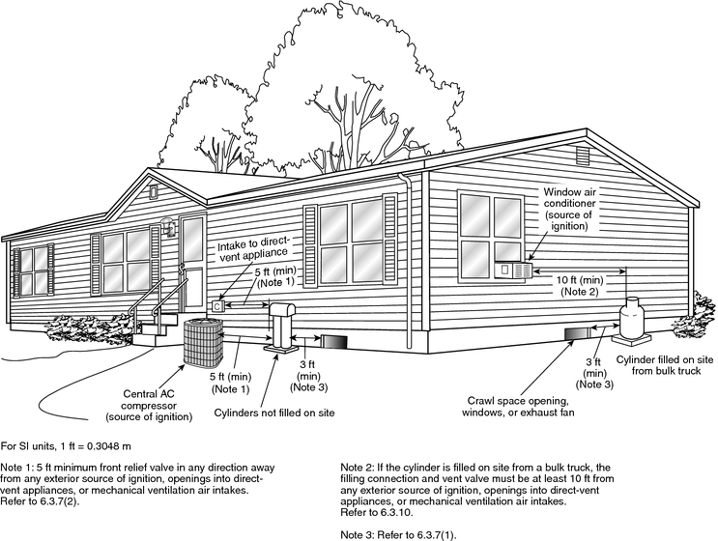
©Reprinted with permission from NFPA 58-2008 Liquefied Petroleum Gas Code Copyright © 2008, National Fire Protection Association, Quincy, MA. This reprinted is not the complete and official position of the NFPA on the referenced subject, which is represented only by the standard in its entirety.

